The nodes on the cluster don’t have internet access so we need to run ollama and neo4j locally. In this guide you’ll have to download them on your computer and transfer them to compute Canada’s cluster and unpack them there to use. If there is an easier way to transport these files to the cluster, feel free to do that, this is just what worked for me.
- Drag and drop all the folders and files needed for mindmap into VS code into the folder you want. There is a branch called cluster-code in the github specifically with the version of MindMap.py you need for running on the cluster as well as an additional file you need – run_alliance.bash that should also go into the mindmap folder.
- Go to this link and scroll down to download ollama-linux-amd64.tar.zst (1.34 GB highlighted in the screen shot below) - https://github.com/ollama/ollama/releases
  - 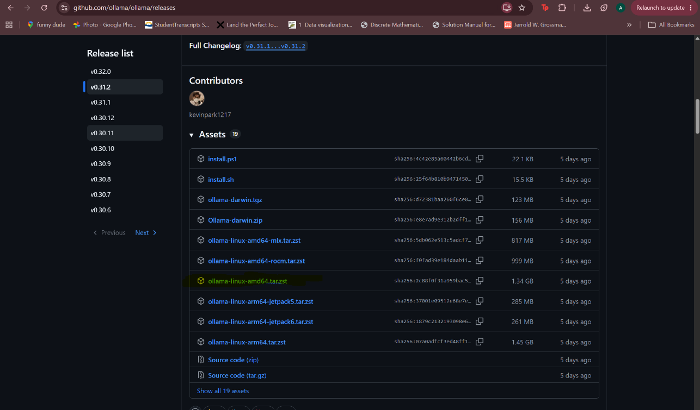
  - Drag and drop the ollama zst file into VS code into the scratch folder.
  - Run these commands to extract the zst file
    - tar --zstd -xf ollama-linux-amd64.tar.zst
    - cp bin/ollama $SCRATCH/ollama
    - chmod +x $SCRATCH/ollama
- Go to this link to download neo4j - https://neo4j.com/deployment-center/?gdb-selfmanaged&community. Make sure you select linux/mac executable like below.
  - 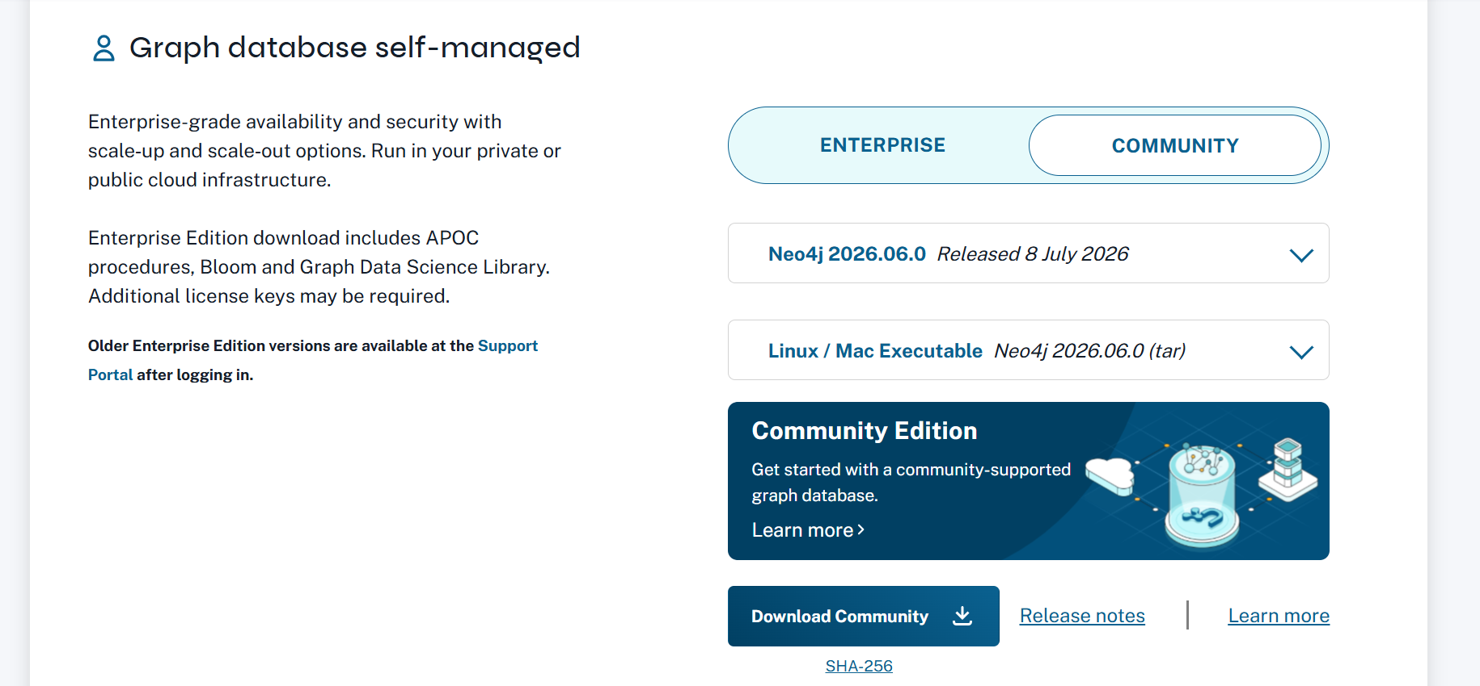
  - Drag and drop the neo4j gz file from your computer into VS code into the folder you want.
  - Run these commands to extract and rename the gz file, configure the database to bypass password checks and clean up files
    - tar -xf neo4j-community-2026.06.0-unix.tar.gz
    - mv neo4j-community-2026.06.0 neo4j-local
    - echo "dbms.security.auth_enabled=false" >> ~/neo4j-local/conf/neo4j.conf
    - rm neo4j-community-2026.06.0-unix.tar.gz

- Change the lines that have comments to change them in the run_alliance.bash file in the mindmap folder. You’ll have to change your email in line 11 and various file paths on lines 25, 29, 31, and 51.
- Open the mindmap folder in a terminal in VS code.
- Run sbatch run_alliance.bash to run MindMap.py.

Other notes:
- The output will show up in the mindmap folder as a file named “output<job number>.out” a minute or two after it has completed.
- One of the SBATCH directives at the top of run_alliance.bash sets the time to 15 minutes for a test run of your code. You can change this to longer after you confirm your code runs.
- You can run the command sq in the VS code terminal to see if your job has been queued after you run it. It may take a few minutes for the cluster to actually start running your code.

